1. Screenshot of new written code
2. Method Overloading

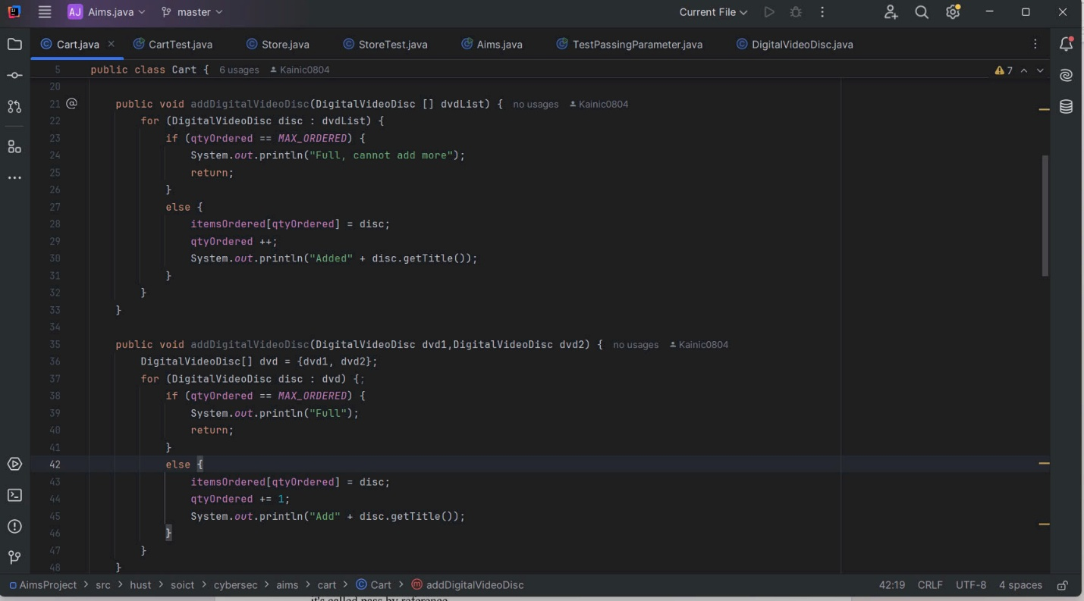

1. Passing parameter

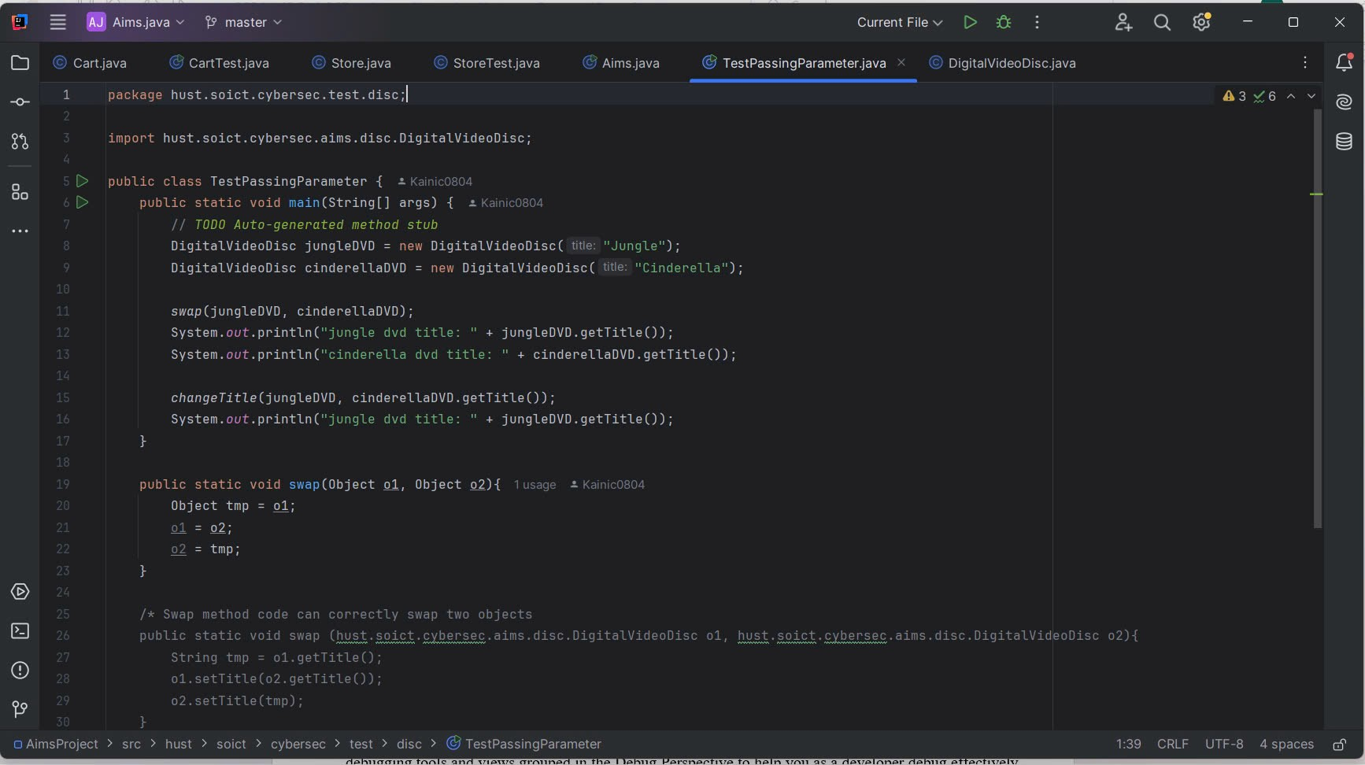

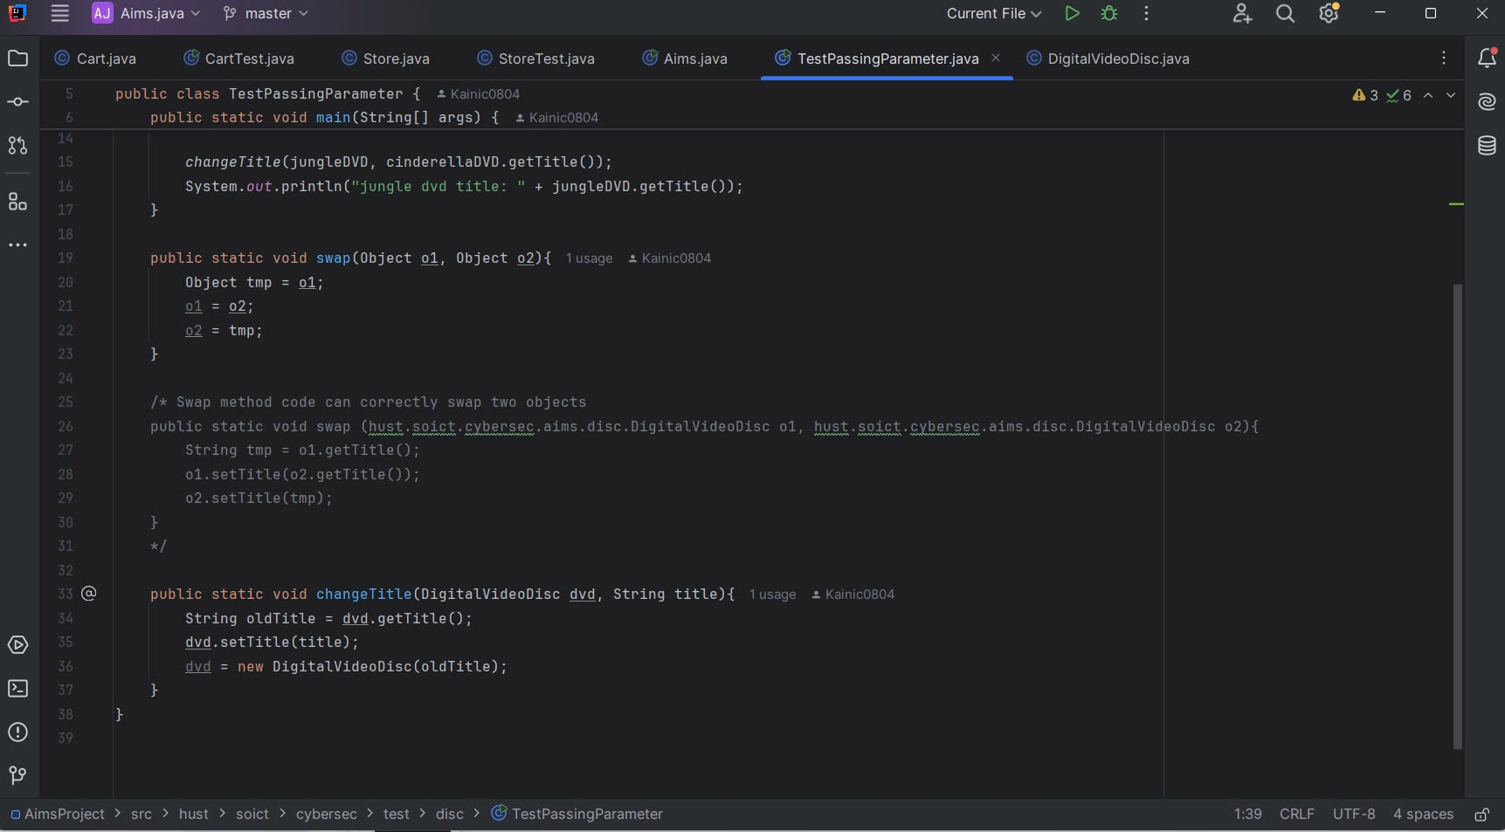

1. Write a toString() method, searchByID, searchByTitle, printCart



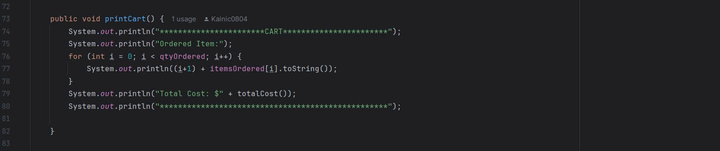

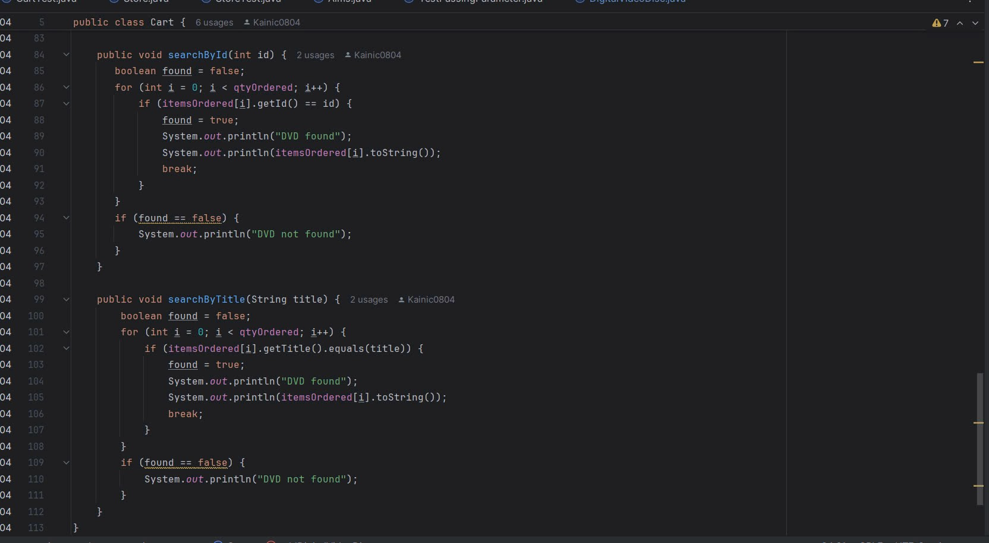

1. CartTest class

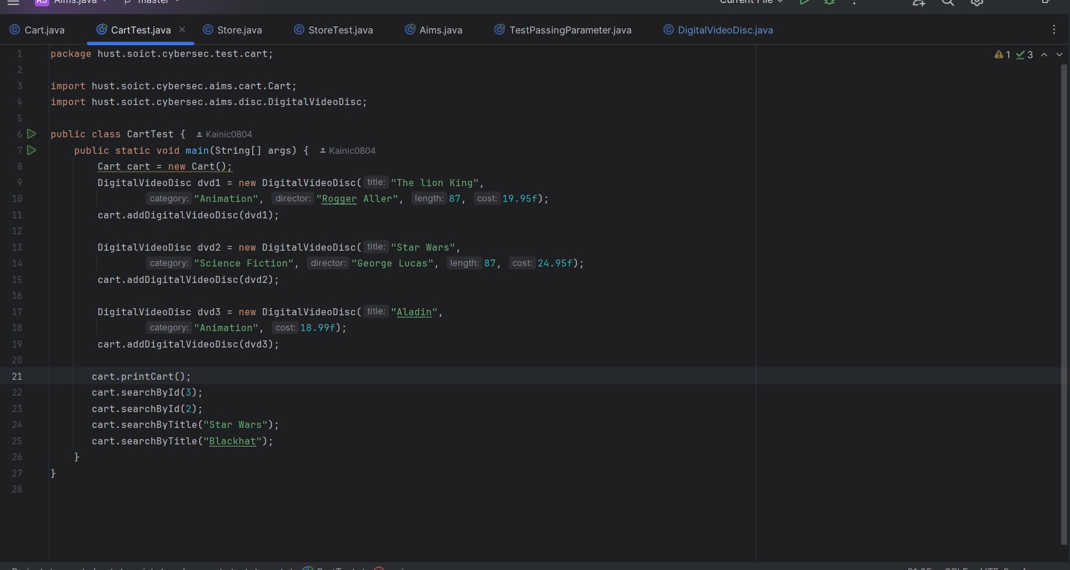

1. Store class

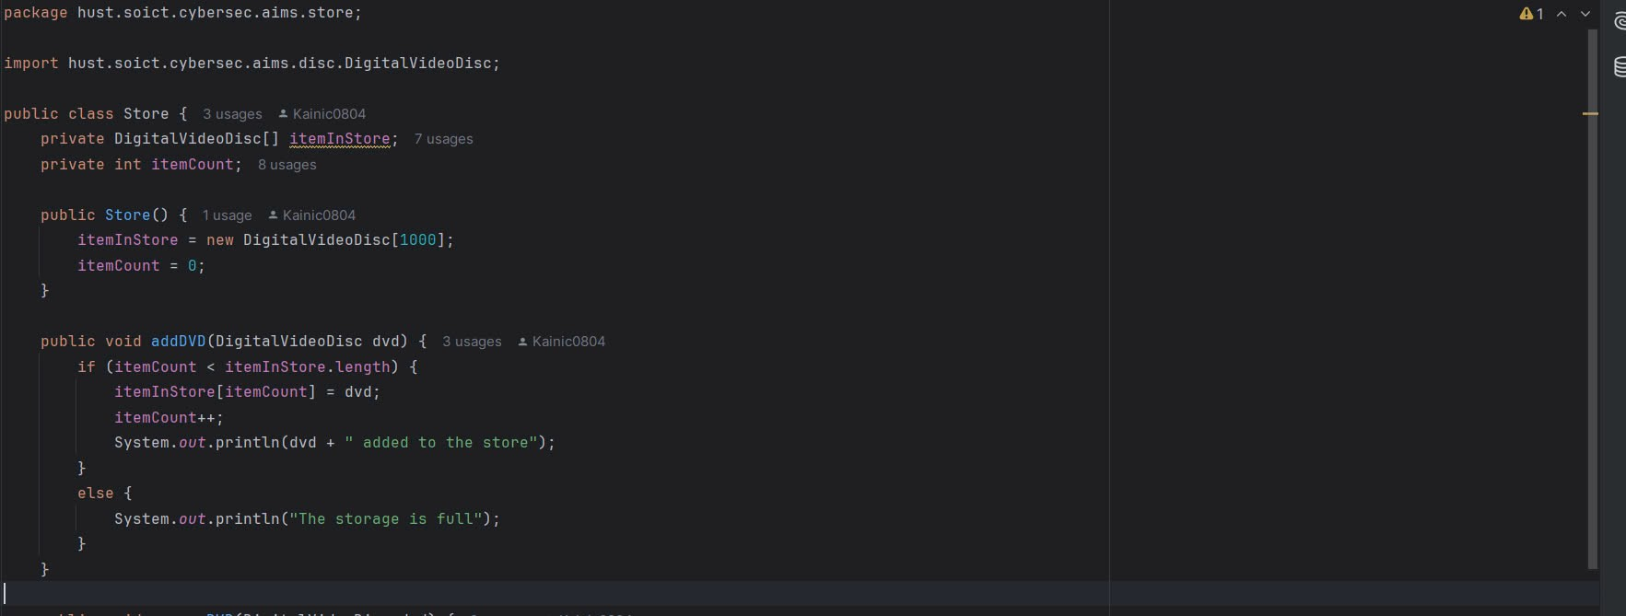

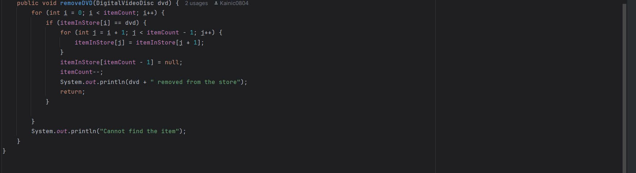

1. StoreTest class

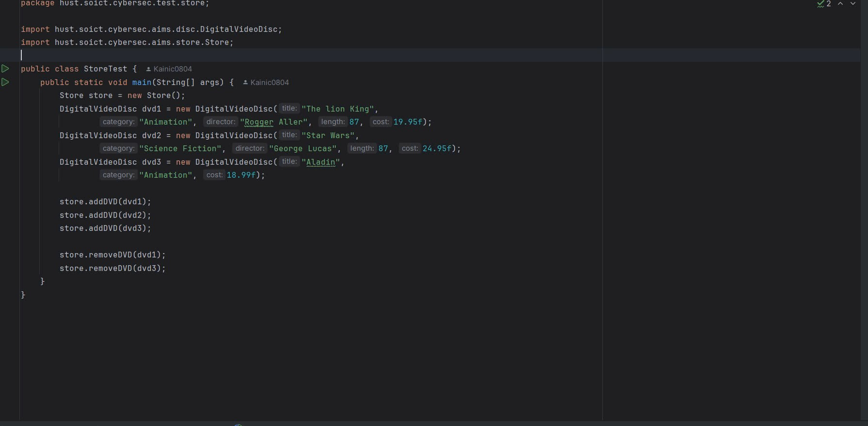

1. Classifier Member and Instance Member

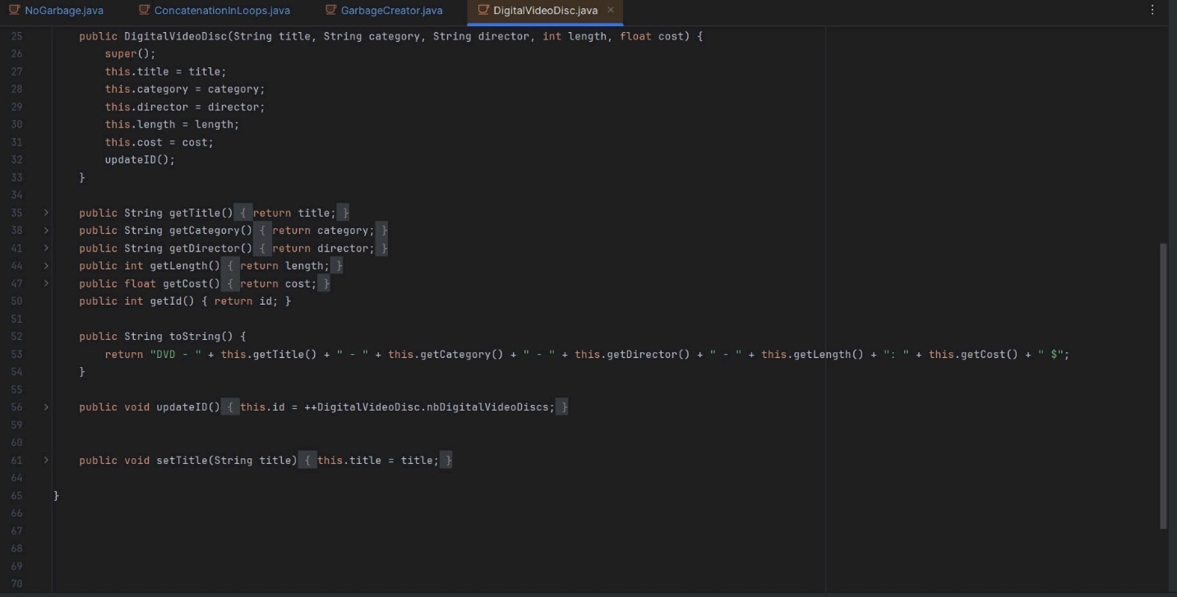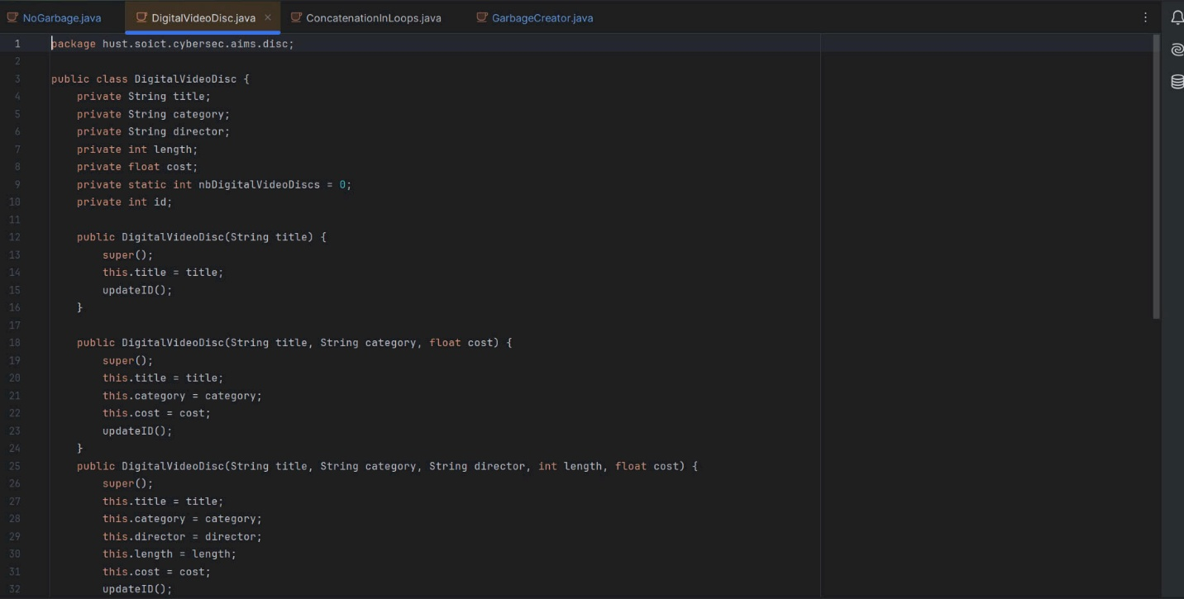

1. String, StringBuilder and StringBuffer

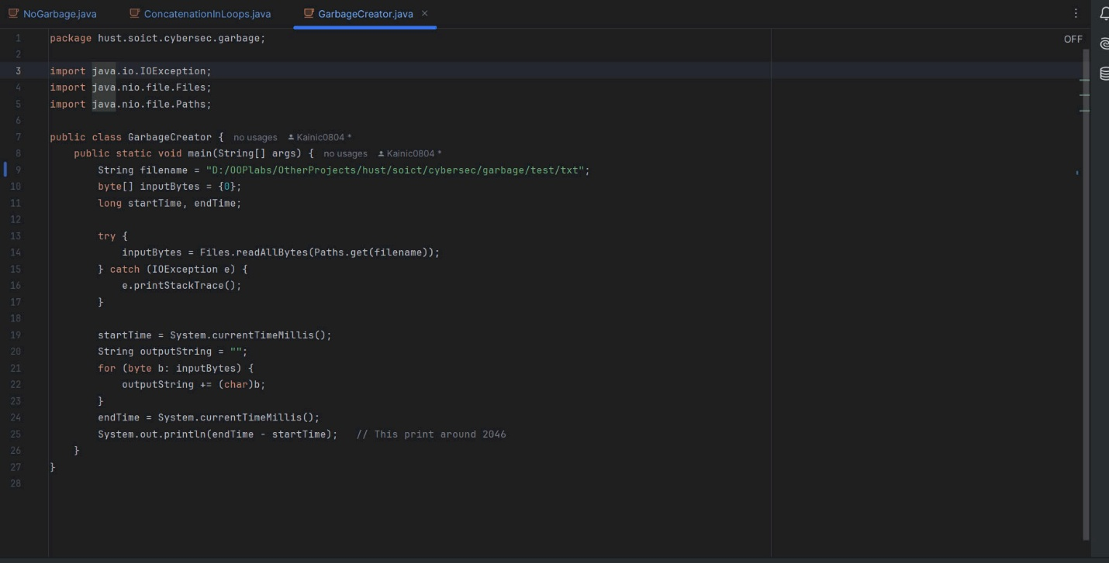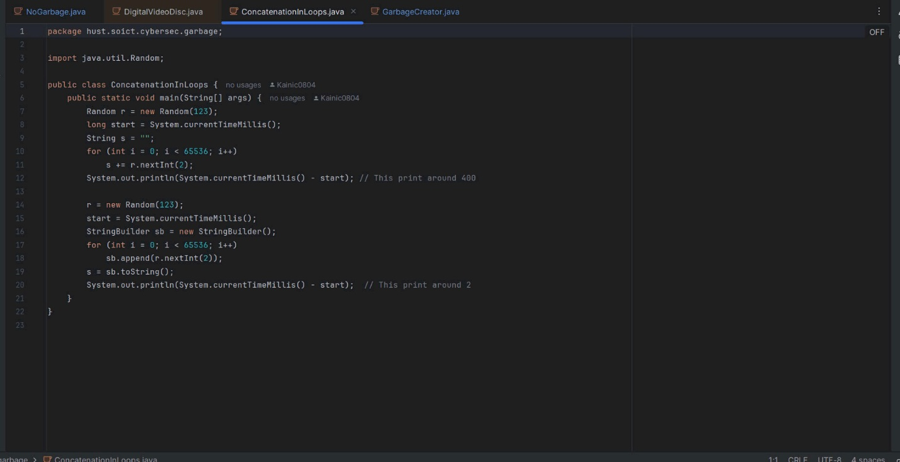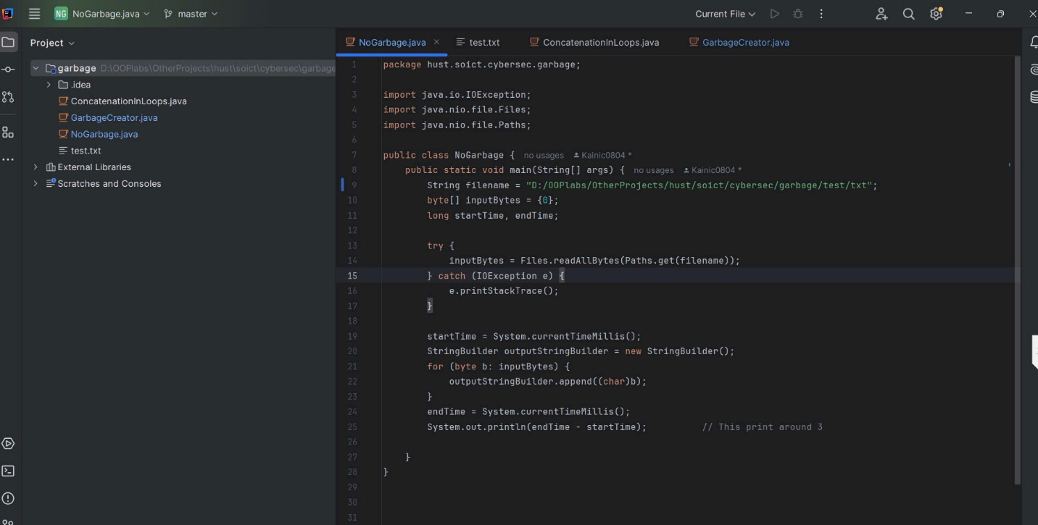

II. Screenshot of code debugging and the results

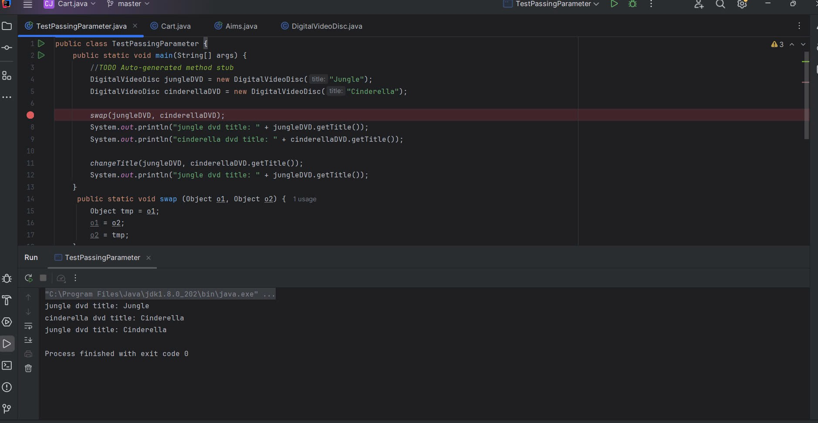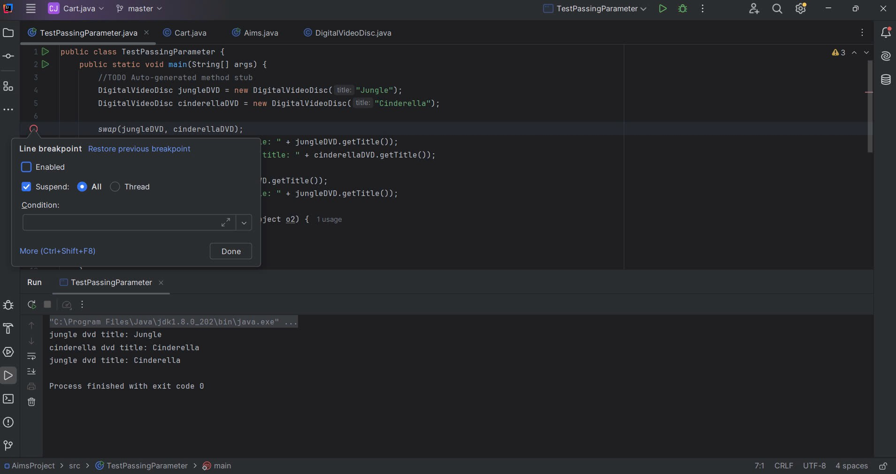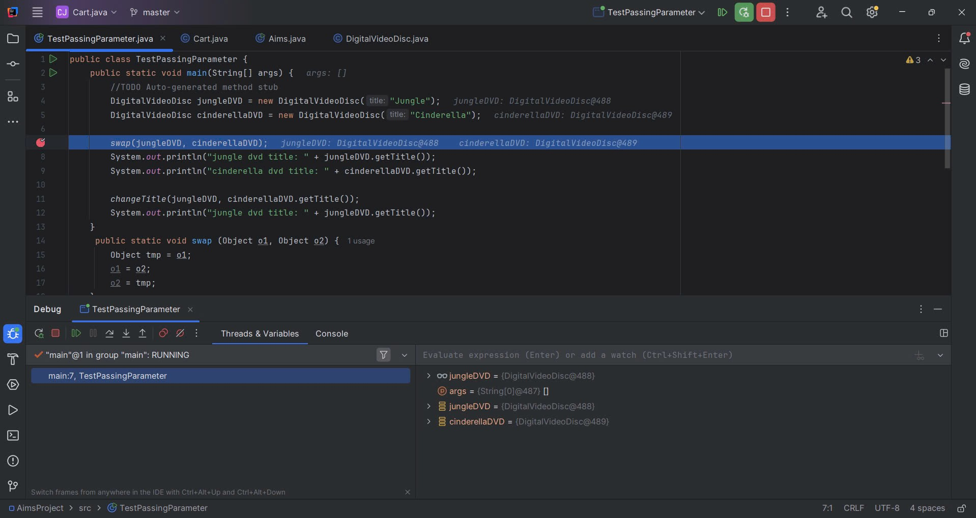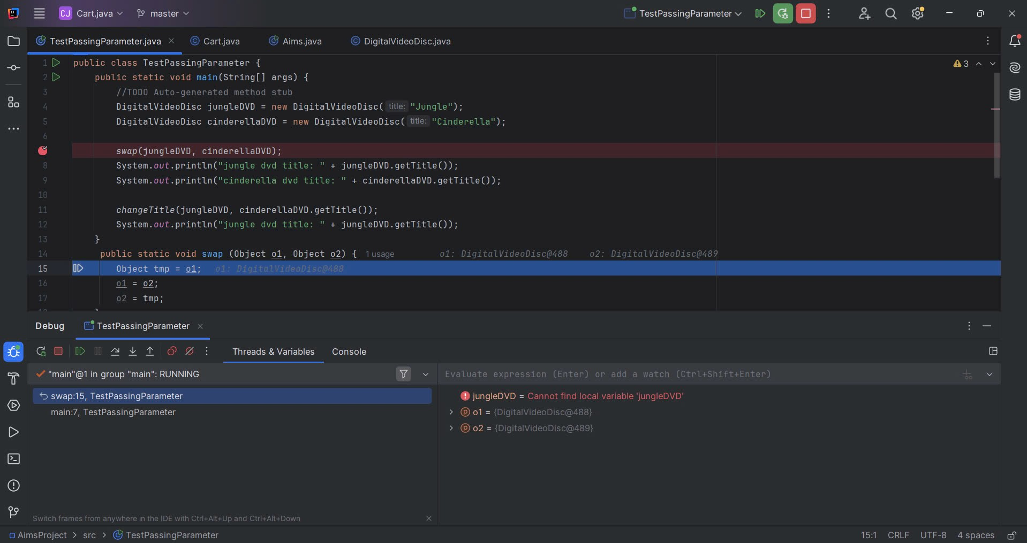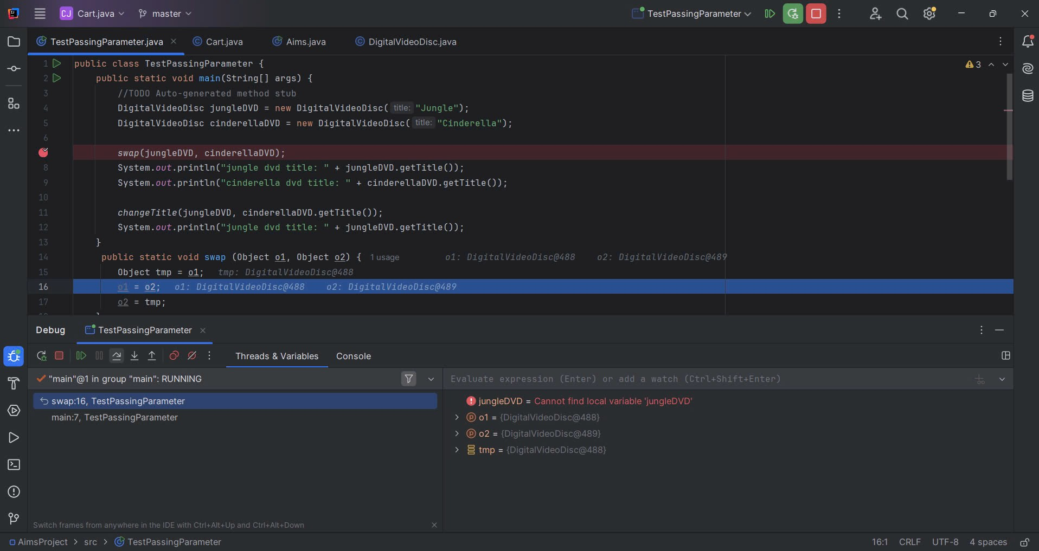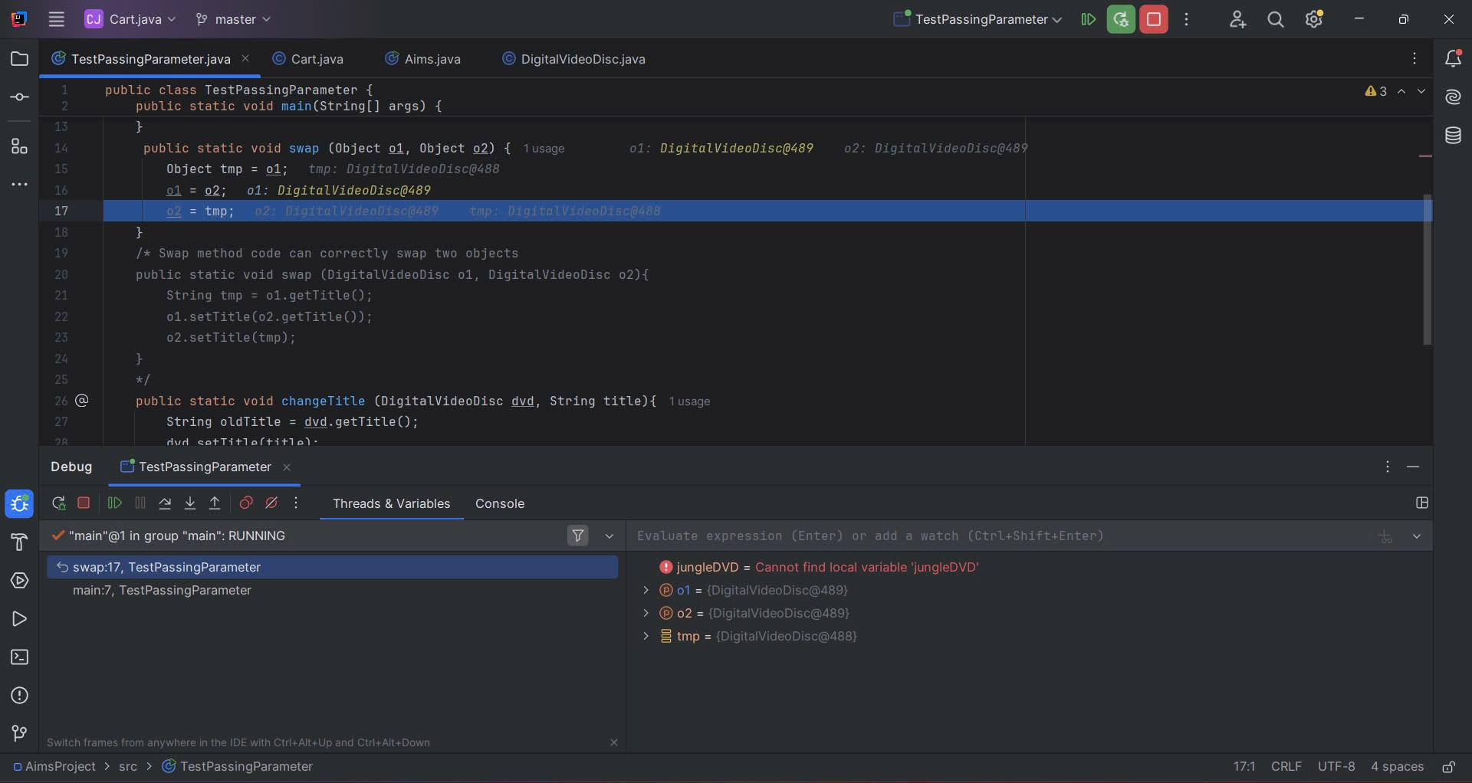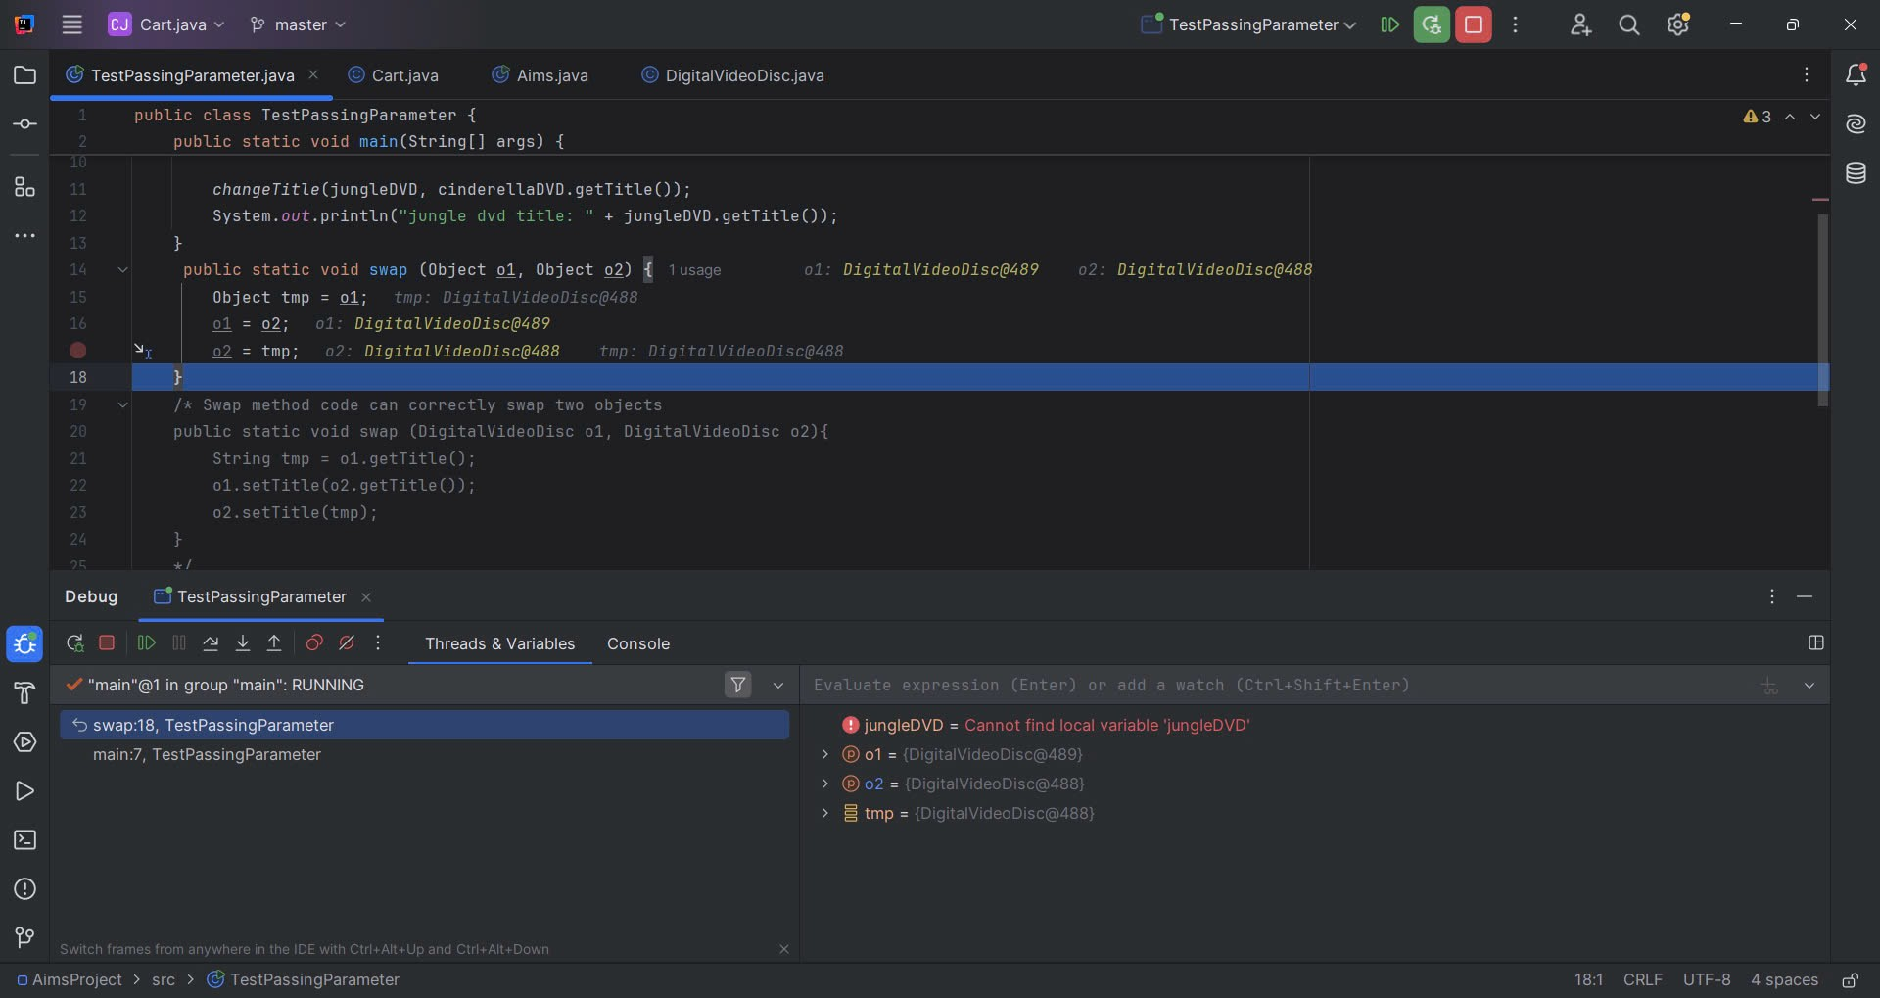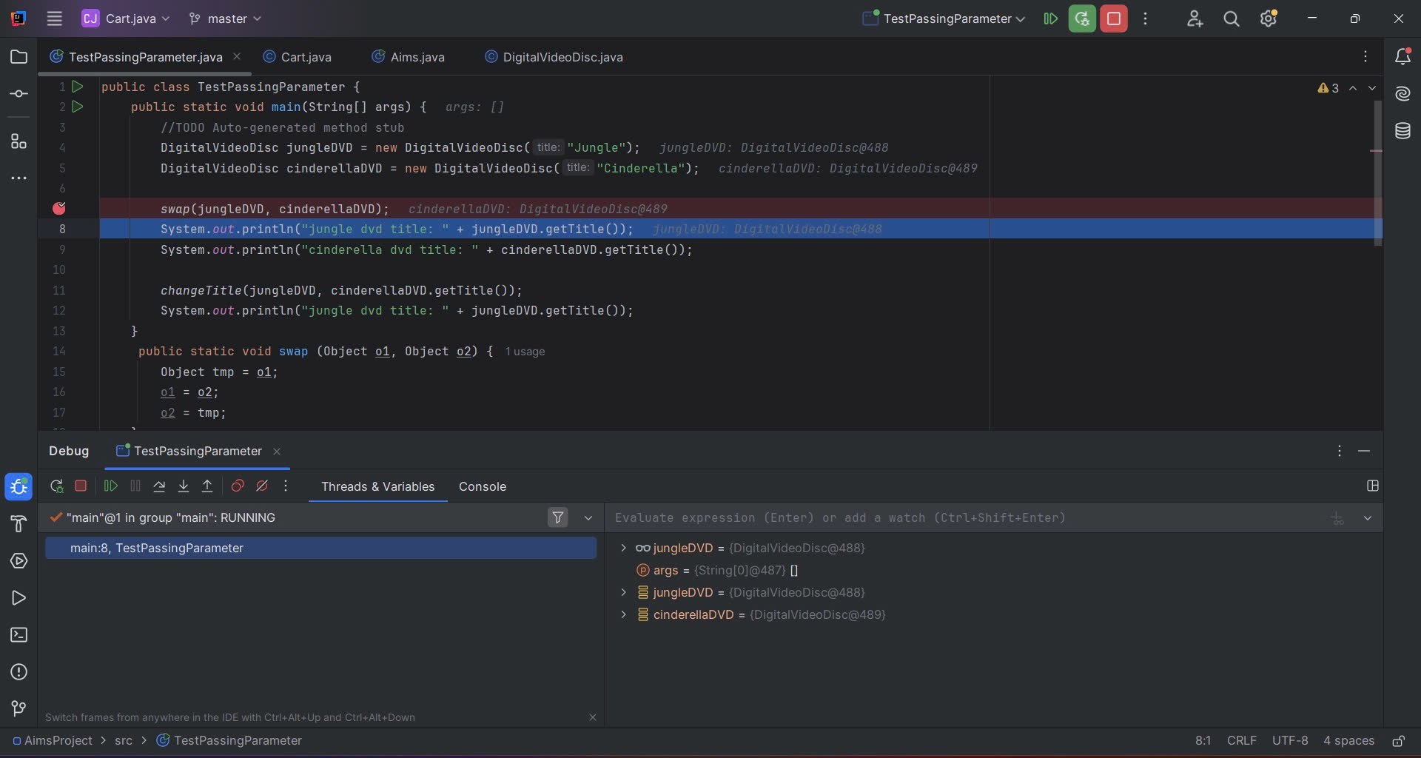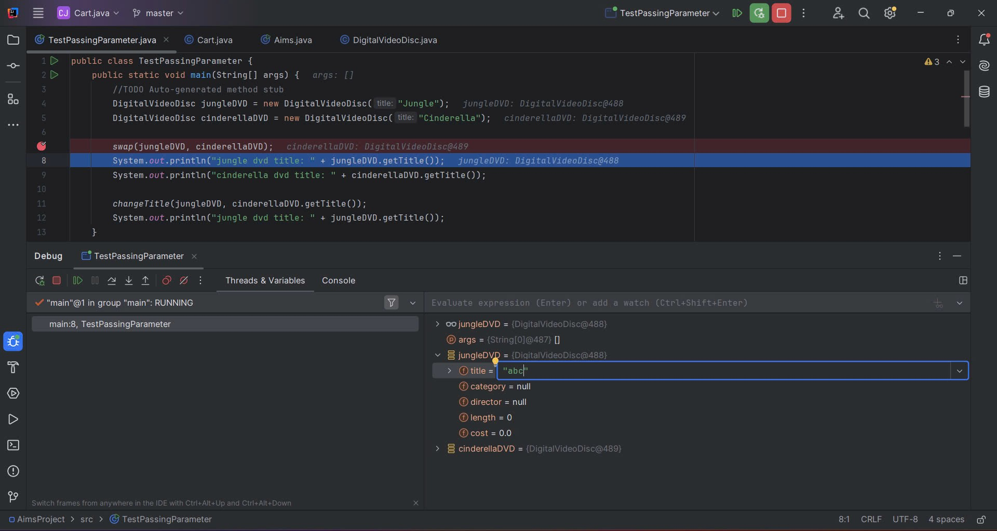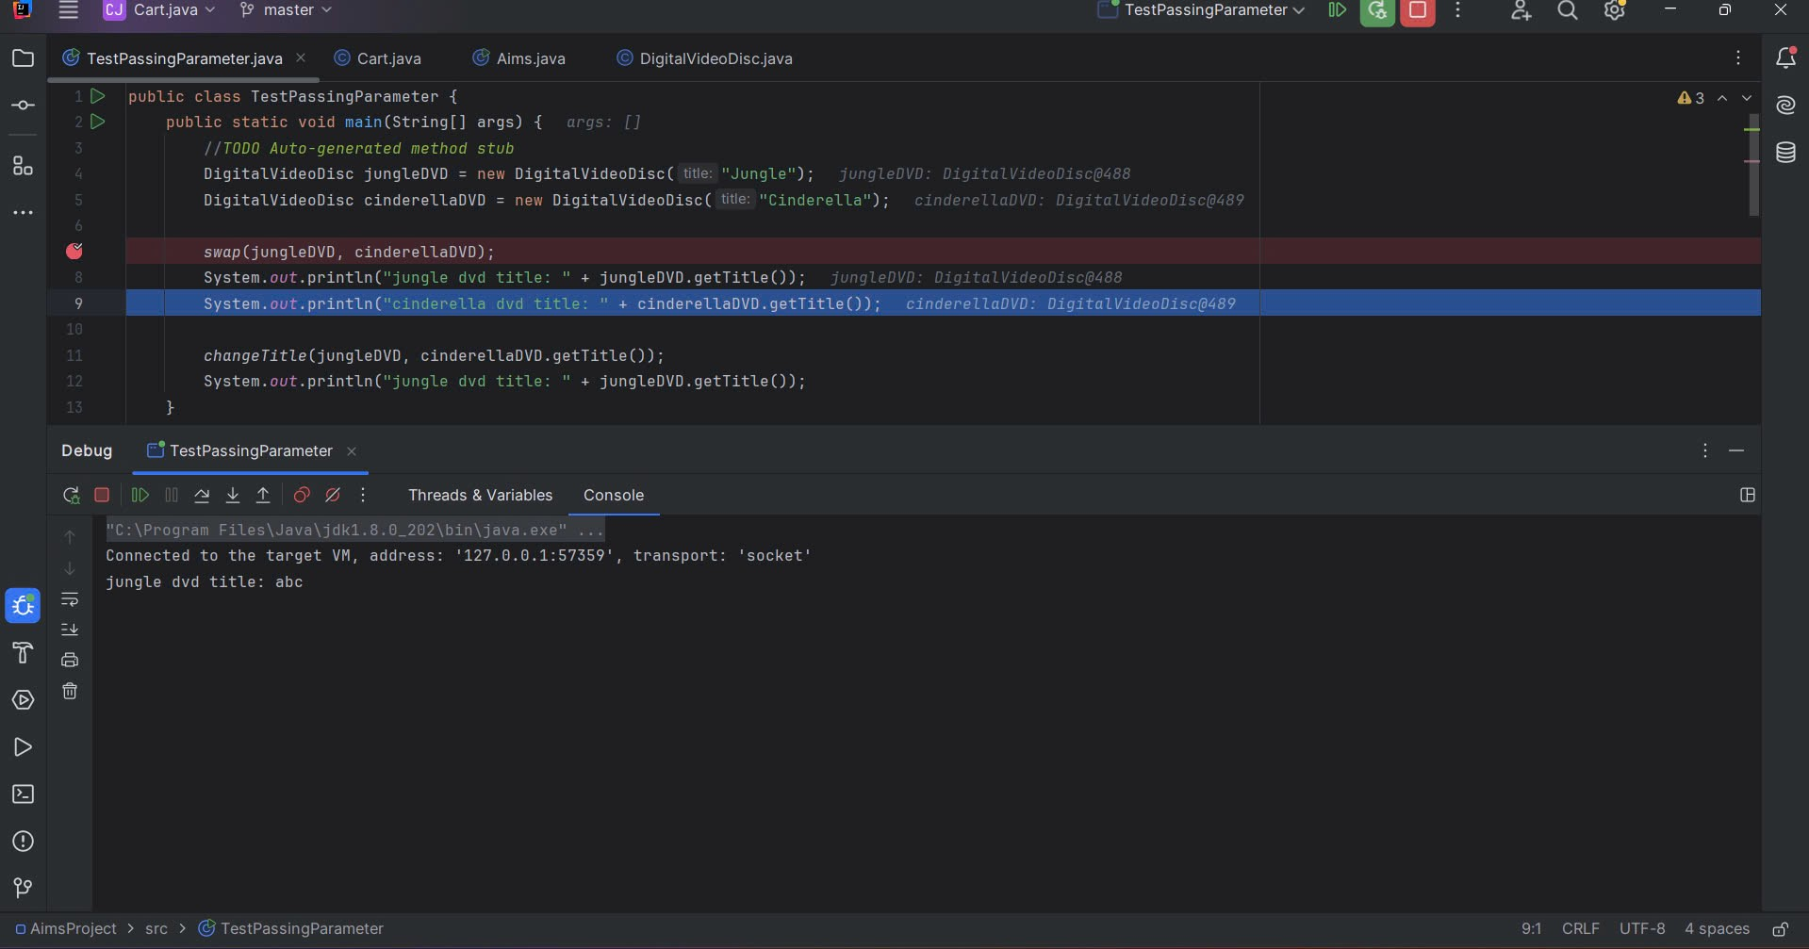

III. Use-case diagram and class diagram

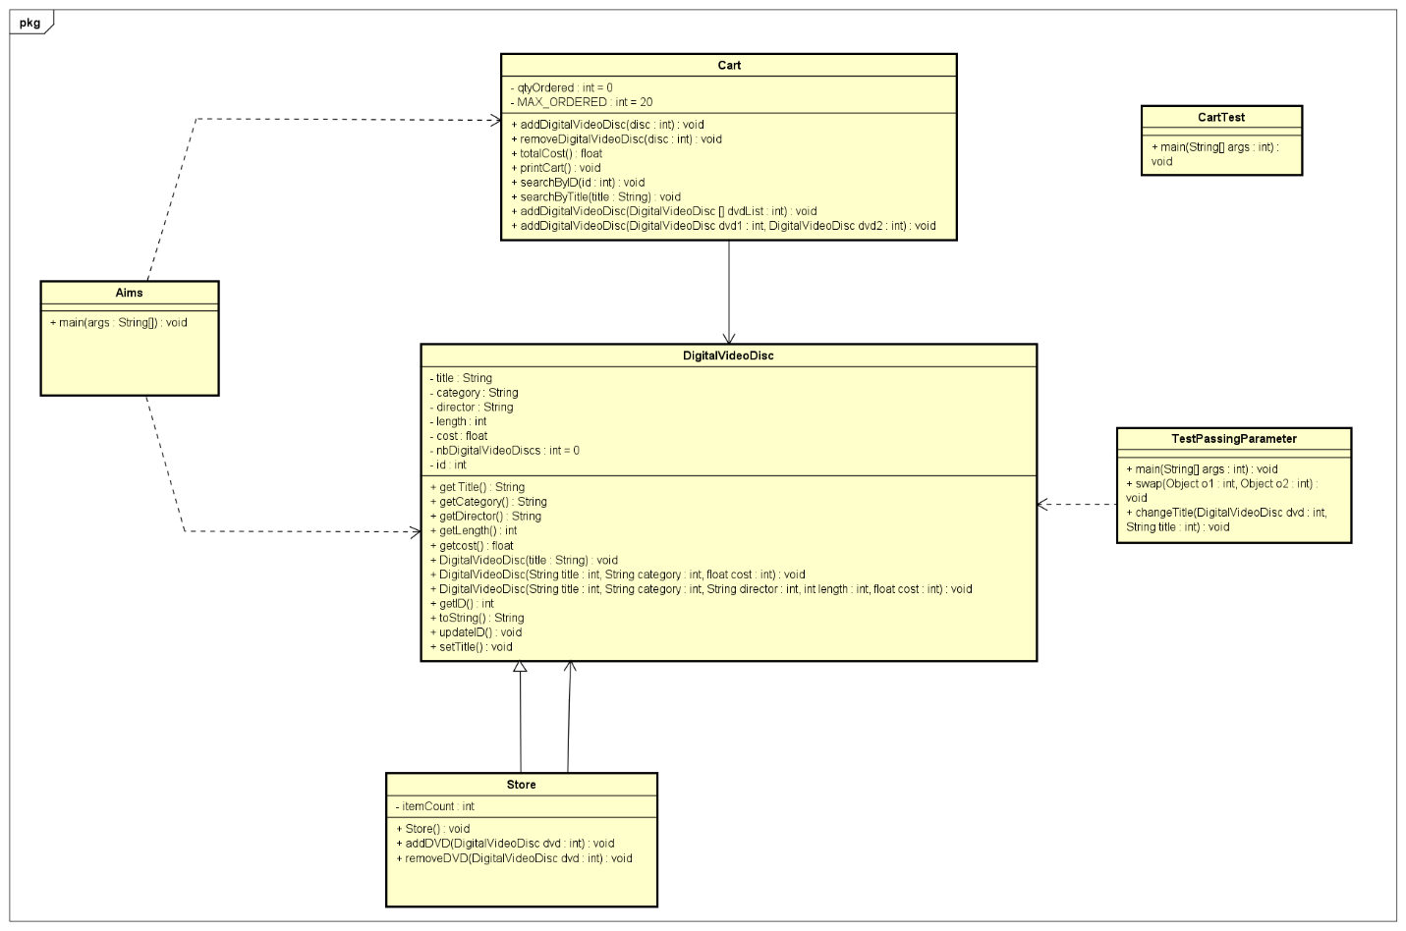

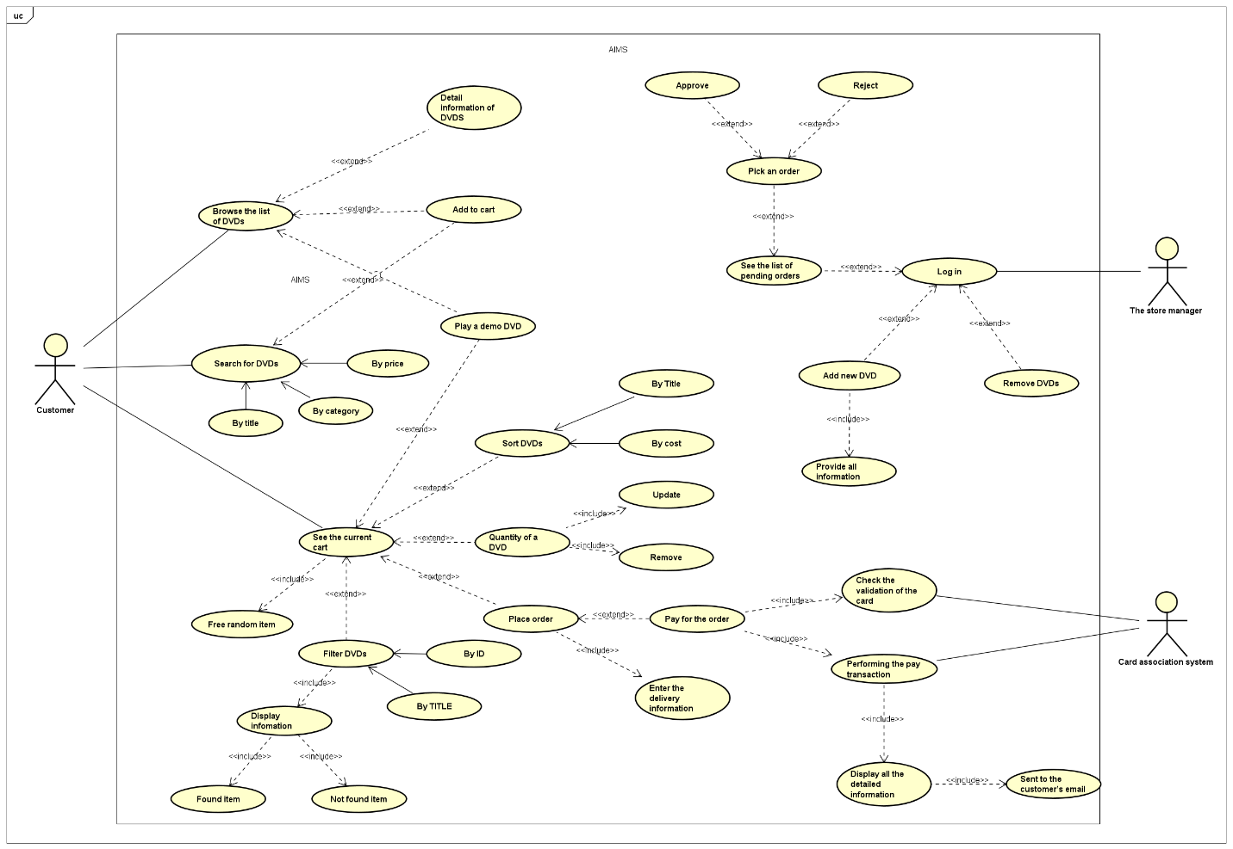

IV. Answer the questions

* ***Is JAVA a Pass by Value or a Pass by Reference programming language?***

Java is pass by Value. We can see after call of swap(jungleDVD, cinderellaDVD), the value of their references are copied into the parameters o1 and o2 respectively. Inside the swap method, the reference o1 and o2 are swapped. However, this only affects the local variables o1 and o2 within the swap method. The original references jungleDVD and cinderellaDVD in the main method are not modified, and that's why the titles remain unchanged in the main method after calling swap(jungleDVD, cinderellaDVD).

* ***After the call of swap(jungleDVD, cinderellaDVD) why does the title of these two objects still remain?***

The value of their references are copied into the parameters o1 and o2 respectively. Inside the swap method, the reference o1 and o2 are swapped but outside the original references jungleDVD and cinderellaDVD in the main method not swapped at all, so title of these two objects still remain.

* ***After the call of changeTitle(jungleDVD, cinderellaDVD.getTitle()) why is the title of the JungleDVD changed?***

After the call of changeTitle(jungleDVD, cinderellaDVD.getTitle()), the title of the JungleDVD changed. The reason is that Java object variables are simply references that point to real objects in the memory heap. Therefore, even though Java passes parameters to methods by value, if the variable points to an object reference, the real object will also be changed.